Module title: | Operations Management and Quality
Program/location: | MSc in Healthcare Management, DUBAI, Year 1, 2018-2019
Assignment title: | Operations Management and Quality
Student ID: | 18161910  18199381
Date of submission: | 26.11.2018
Word count: | Part A:
Word count: | Part B:

Context
A mapping process is a significant tool as it captures what’s happening, provides a broad view of what’s going on and helps in achieving further improvement (Miller & chalapati, 2015)
This process starts when the patient enters the clinic to see the physician as he has to pass through a few steps before getting the treatment. First, before the registration, he has to take a number from a Qmatic system and waits until his name appears on the screen on top of the medical record as there is a male registration and female registration as the patient can choose from the Q system whether male or female. This process will take from five minutes up to ten minutes from entering the clinic until reaching the registration.
Then if the patient is new and doesn’t have a health care card or records, he has to pay for the health card number and to fill a form regarding his personal information. Otherwise if the patient already has a health card number, the medical record will register the patient and transfer his Qmatic amount for the nurse assessment. Again the patient has. To wait in the waiting area as there is female and male waiting area until his number appears on the screen for the nurse assessment.
As there are only one male assessment room and one female, the assessment room which covers the patient for ten doctors, therefore, the patient has to wait from 30-40 minutes, in the assessment room the nurse will check the vital sign like blood pressure, temperature, heartbeat, and the oxygen saturation. The nurse will review the heights and weight, ask about the current complain and if there is any medical conditions or allergies. This will take from five up to ten minutes.
After that, the nurse will send the patient again to the waiting area and will transfer the patient Qmatic number to the physician. As in Salama system of the physician, it will appear that the patient is ready for the physician. During this time the patient will wait in the waiting area until the physician calls him, in this step the patient can wait up to 60minutes and here is the bottleneck as the longest waiting time, as there are many patients with less doctor to cover. Furthermore, the physician has to see an unlimited number of booked patient and each patient will take from fifteen till twenty minutes according to each case. This whole process takes minimum fifty minutes and maximum up to two hours.
Regarding the process of patient journey from entering the clinic until seeing the physician, he passes through 4 steps. It takes approximately twenty minutes between each level. Furthermore, the main bottleneck in this process is waiting time to see the physician as takes up to sixty minutes, while the functional bottleneck happens when the physician suddenly has emergency cases which takes longer time and affect the patient flow.
This mapping process also shows the demand is much higher than the available capacity of resources like nursing staff, physicians and the clinic facility like treatment room .besides some steps have no values and add more time like waiting time before the registration. Instead online booking can solve the problem to improve the bottleneck; the capacity must be higher than the demand.

Fishbone analysis
There are many tools regarding quality health improvement. , like fishbone analysis and five whys, discussed.
Investigation of a problem, a fish bone analysis will be used to identify the causes and the constraints of long patient waiting time.
The leading causes identified as follow: first physician causes which include poor health education to the patient regarding when to come back or follow up or poor communication skills of the physician — moreover language barrier With some patient also less number of a physician due to a high number of physician resignation as a result of the physician burnout or absent of appreciation of their work.
Moreover, some physician will take a long time with the patient either due to fewer qualifications or experience or due to severe cases.
The 2nd cause is the environment as there is only one treatment room with four beds just so that the patient accumulates thus lead to long waiting time to receive treatment.
Also, there is only one male assessment room and one female assessment room which cover the patient often doctors, and that is why the patient waits from twenty to thirty minutes until the nurse assessment.
The third cause is related to the equipment: sometimes the Qmatic system is not working, so the nurse in the assessment room has to call the patient manually which interfere with her job. Furthermore, there is a shortage in the nursing staff, and there is no clinic for emergency cases as those cases affect the patient who is waiting and lead to long waits time. The fourth cause is related to the method which is a walk-in clinic so that any patient can attend without an appointment with unlimited overbooking for each physician. Furthermore, there is no triage system, and there are so many documentation for the nurses and the doctors .the fifth constraint is people, high population size , some patient skip the queue, patient with frequent clinic visits or who comes for sick leaves only and patient who doesn’t know how to use Qmatic system.
Five Whys
One of the standard root cause analysis is five whys (conger, 2011; likes and Meir, 2006), and it involves five questions starts with five whys.
First, why the patient waits for a long time?
Why there is one assessment room?
Why there is less staff?
Why there is a high number of resignation?
Why there is overbooking?
These are the cause that leads to patient delays and long patient waiting time.

Discussion

To begin with, we identified our problem, which is waiting time, and wrote it in a box then drew an arrow pointing towards it. We identified all the parties involved, and where and when the problem occurs. After identifying significant factors, we pulled four branches from the central arrow to represent these “major” categories of causes. In our case, we found out people, equipment, physicians, procedures and environment to be the most likely causes of increased waiting time in clinics. After this, we brainstormed to get the specific “causes of the identified causes.” Usually, it is allowed to have sub-causes where the causes are complex — all of these shown as lines from the particular object. When the quality of healthcare systems is weak, the results are poor for taxpayers, staff and most importantly, for the patients. The introduction of the Quality, Innovation, Productivity and Prevention (QIPP) agenda led to the sprouting of many questions.
First and foremost, there were queries on what would happen to cost if the quality of care and timeliness are improved? The other question was: Is it possible that patient outcomes and healthcare access continue growing even with less resource? In our pursuit to answer these question, we realized that the cause of increased waiting times is in the circles of human resources, the environment, equipment used and the criteria followed. It is not accessible to precisely point at one factor to be the sole cause universally; this is because the states of affairs differ in different locations (Tiamaz, 2017).
Researchers have come up with various methods that are all geared at improving to the level of having safe and person-centered care that is effectively available for every patient, all year round whenever it is needed. For achievement, there has to be an improvement in the staff and patient experience which takes action backed by respective essential elements. There should be an empowered and clinically focused management. (Chen et al. 2008). Secondly, there is the need for health centres to be flexible enough to allow for the realignment of patient flow and capacity to fit with the situation at hand; this is achievable only if there is the proper understanding of the demand of patient flow and alignment of available ability to handle the situation. The right beds need to be in the right place; this is to help avoid confusion at the time when patients arranged inwards. Without adequate support to keep the rate of flow up and consistent, it would be a waste of time.
There is this one major problem that we found familiar in most of the peer-reviewed articles we went through. Bed management instead of focusing on patient management. Once patients admitted, electronically where applicable, there should be a system linked to the health care centre that can monitor the patient’s movements. Staff in charge of ensuring there is proper patient flow should provide that the daily discharge from the centre by unit, ward or site is in balance with the anticipated admissions. It is also advisable to avoid conducting unnecessary transfers. Instead, focus on ensuring the patients in the facilities services to the best of ability. Estimating the date of discharge helps in planning on the balance between capacity and demand (Rutman et al. 2015). It is unfortunate that we have had such a strategy for too long. The need of estimation on the capacity of a clinic serves a key aspect in reducing the extent of waiting, and service delivery as the number of the patient admitted are in the same ratio with the clinic capacity, this includes beds and medical practitioners such as nurses and doctors.
We were able to look at surgical and medical processes as a contributor to the improvement of patients and staff experience in depth. We realized that access to senior medical practitioners and or decision-makers remains to be a challenge. Therefore, the critical contacts for healthcare hotlines and ambulance service providers should be reachable al round the year as long as they are on duty. Sometimes, the delay begins from outside the clinic. For example, in the case, one is caught up in an accident and can not avail the ambulance hotline since the line is no longer working. (S) He is forced to wait until help comes from elsewhere. Supposing there are delays from the previous day in the health care centre, with such cases happening, there would be more people losing lives due to some few people’s negligence’s. Diagnostics should be easy to access. It should be prompt. Clinics need to ensure they do not run out of medication. At no time should a patient have to buy their medication from a chemist outside when they received all other services from within. The hospital chemist should have it. Focusing on the delays arising outside the clinic, the government in conjunction with the health system should focus on establishing multiple systems to respond to an emergency such as ambulances and response team working all around, day and night. Access to surgeons and consultants should be a patient-centred approach as they have adequate experience to reduce the waiting time and increase service delivery to the patients.
Most clinics do not operate for seven days of the week; this on its own is a contribution to having delays in service delivery. Some facilities may work for the entire week but be as good as the ones shut over the weekends. It is possible to find workers in clinics who seem to be there just because they have to and are entirely unwilling to serve. Most of the people who contributed on this confessed about having the first-hand experience with such clinic attendants. Accidents happen unplanned, unexpected. Suppose my brother gets injured in hand on a Sunday morning. Then the only clinic within our means can only be accessed on a working day. On Monday morning when I take my brother for medication, it is possible to find a dozen other people with a problem that had been waiting too. If at the start of the day there is traffic already, it is difficult to end that delay especially in a clinic scenario where every other detail keenly considered for informed decisions made. The service to keep the public health in good shape should be a calling. People who choose to pursue this career ought to be kind enough to sacrifice a whole lot of things to serve; family time, leisure and get used to working out of hours. Emphasize to insist on continues working hours and days help reduce long ques and improve on service delivery to the patients.
In the past, most clinics did not offer their services to patients in their homes. Nowadays, things have changed. Quite a good number of interviewed medical practitioners have argued that they prefer this than having to be at the clinic. Some claim that it is more convenient especially when the patients are from a particular neighbourhood for example (Kaplan et al. 2009). Similarly, patients also seem to enjoy this service with most citing that the wards in hospitals are too overcrowded for one to recover.
All in all, even when the patient had been admitted and is now ready and fit for discharge, there is need to extend your invitation for anything that may come up, on your client, as the practitioner. It is advisable to offer patients short stay assessments once discharged. When necessary, it is better to redirect for assistance elsewhere rather than have admitting them and not serving them to their expectation. If a patient is fit to stay home until further notice, it is unwise to book the individual just because they have requested (Hoot et al. 2008). Managing the admitted patient’s databases is difficult; the higher the number, the harder the task. For us to make the systems simpler to handle, there is a need to implement the key aspects. Accurate training of the medical practitioners to deal with patients challenges and determining their condition help improve and reduce the extent of admission and reduction in waiting on ques to receive medication.
Optimal care for patients can be achieved by understanding the clinic Safety Flow Huddle, a document by the Scotland NHS; this can be done by making the system better. Integration with a broader network and ensuring leadership are contributing factors to a more efficient and effective operation. For combination to be possible, communication has to be present to share the expectations by the organization and ensuring the environment created is supportive of psychological safety. Every stakeholder has a role to play in improving the quality of health care; this implies that there is need to follow up on non-attenders and help them catch up with the daily briefings (Bullivant, 2000). Full participation is essential for consultations which lead to informed decision making. Coordination with all sectors of health and all workers in the hospital help reduce the system delays in the clinic.
Effective system management will determine by effective leadership. The success of huddles solely depends on people and their participation. Leaders during these meetings should be conscious enough to recognize the uncertain time, creating chances for resolution and learning and to openly appreciate teamwork and resilience. Congratulating an individual for good work done boosts their self-esteem and morale to work even harder to achieve better results. The one in charge during meetings should always focus on leading the team by joint responsibility which would ensure people are at the right place at the right time. Before the start of every huddle, it is wise to check that there are expertise and capability to address safety awareness, improvement skills, strategic plan and front-line alignment, risk awareness, learning by way of assimilation, senior medical leadership and consistent, effective delegation of duties (Pickerden et al. 2015). Clinics governed with a single head charged with decision making. A variety of stakeholders are involved in a practical decision such as determining the number of admissions and employment of attendants in the hospital. The effect decision making is the basis of reducing waiting in the clinics.
A system that encourages analysis of flow status and planning is a crucial contribution to the improvement of the quality of service to customers. During briefings, there should be enough insight into hospital capacity or bed management; this has to do with whether the available beds are enough to meet the expected demand. To minimize waiting time in the clinic, we also focused on understanding the benefits of managing the structure of operations in the clinics. There is a lot that medical practitioners can do to move towards a useful structure. First, there should be the provision of a reliable data collection format that will support predictions on admissions and discharge. Feedback toward information should be via agreed script (Cordeiro et al. 2015). The chairperson should be in a position to issue notes that outline the text. An electronic template should always be available to capture the location of the whole system at specific times. Implementing on the agreed policy reduced the incidences of over congestions inwards and unnecessary admission to reduce on waiting time as the capacity of patients in the hospital is determined to the number of resources available such as medical attendants, wards and operational rooms among other.
An important aspect that helps grow an organization’s system and structure has time to learn new behaviours and to model. (Pandit et al. 2010) During this time: predictions for the day made, there is a countercheck to see the effectiveness of the forecast for the previous day and potential risks identified. It is almost sure that there have to be some predictions that did not go as per expectation. These are the learning points where there is an analysis of what was done to achieve the current results and what could be better? All challenges that the team anticipates for should be considered with concern. The structure can also be made better by having problem-solving strategies. Such strategies revolve around responsibility and authority for example. Here, it may be the best action at times to allow for the frontline to experience executive reinforcement. Decision making should be all inclusive and not done by one or a few individuals. Every opinion should be heard to ensure no critical dynamic is left unattended. Management by the reaction is not as effective as managing by prediction; if the management team has to wait until something happens for them to react, it means someone is sleeping on their job (Grol et al. 2013). We should all be proactive if we are determined to end the issue of slow patient flow and long waiting time for patients. If the clinic makes the advanced prediction on the patients admitted and those discharged a balance created that reduce the long waiting. Projections are done through good record keeping and comparing the rate of people visiting the clinics in the previous years.
For ease of solving problems literally before they happen, there have to be tools to aid in the same. Among them is ensuring the team has skills that enable them to gather real-time data to avoid using figures that are guessed or even exaggerated. There is a need to have priorities chosen right to ensure that the critical operations handled first. Also, workers in our health care centres need to be bias-free. For example, a relative or friend should not be allowed to skip the waiting line just because they are known and or close to the attendant. As a team working together to end a common problem, there should be a sense of collective responsibility and mindfulness for issues that arise. Timeliness in responding to questions is essential (Medeiros et al. 2008). However, if the prediction for expected problems turns out to be positive, the likelihood of delay I response is low to zero because at the start of the issue it can be identified and handled.
According to the clinic Safety Flow Huddle document by NHS, we noted that faster patient flow significantly boosts safety. Everyone needs to be away from the danger which would remain a dream for many patients and who have to visit public health care centres, for example, due to the commotion that leaves one feeling unsafe. There are various points that we found necessary for there to be a positive change in the flow and safety of patients. First, early mornings were noted to be the time for the transition which approximately should take a maximum of thirty (30) minutes from 8.00 am; this should advisably be done on a daily basis including weekends. During the day, huddles have to come up where re-assessment of earlier predictions done, progress updated and to ensure the provision of real-time information. Goals that the team wishes to achieve at all levels that are micro, meso and macro, should be concise. Last but not least, the roles and responsibilities of every party should be clear to avoid overlapping of duties which is a waste of time.
Process Mapping
After using the above discussed tools, it was now easy to come up with a representation of data flow. The role of process mapping in this project is to provide a reference point (Trebble et al. 2010). It begins with a stat button then all the activities that fall in between up to the end of the project as shown below.

Start
Data Collection:
Interviewing, Brainstorming, Fishbone Diagram and VSM

Facility Identification
Feasibility Study

End
Data Analysis
Data Presentation and Recommendation

Conclusion
Poor patient flow often leads to increased waiting time for patients before receiving treatment. Moreover, there may be sub-standard care from the attendant once a patient gets the opportunity to be served. The leading cause for this has been the pressure the clinician has when they see the queue that awaits him or her to help; this could be deliberate or accidental (Drowding et al. 2015). There may also be a delay at the time discharge which is mostly caused by lengthy procedures avoided through implementing Criteria Led Discharge (CLD). I was shocked by poor methods of patient discharge that a majority of clinics used the old way of bookkeeping to discharge patients which were bulk and involved lengthy procedures. In this project, we first identified the cause of the problem and then researched the purposes of the reasons to come up with the most suitable solutions.
At the end of our study, we established four basic strategies that could significantly improve the quality of treatment in clinics by reducing patient wait times. The long waiting time attributes to the poor clinic planning on service delivery to the patient and the detailed analysis of the structure of the clinic which included small spacing, low number of medical practitioners and poor infrastructure with technology to improve patient output. It was very discouraging that the doctors used the old technique to diagnose patients that took too long increasing the waiting time, another factor attributed to the inadequate training lead to poor diagnosis eventually leading to unpredicted admissions into wards in large number. Emphasis on advancing technology and adequate medical training should be employed to meet the patient’s demands and reduce on waiting time. Several considerations are made to determine outflow of service delivery Firstly; we considered revamping the process in the front-line scheduling; this takes into account that demand and supply need considerations while scheduling for surgeries and other procedures that are not life-threatening. Secondly, reducing wait times needs to be incorporated as part of the culture in clinics. Thirdly, let services be patient-centred and not provider-centred. Lastly, consider other options to deliver health care services. For the Emergency Department (ED) patients, telemedicine would work well (Di Somma et al. 2015). Clinics should be willing to partner with Urgent care centres nearby to avoid keeping patients waiting.
Improvement tools
The table below shows Quality and service improvement tools with the type of task, first row, and tool overview, on the first column.
 | Project management | Problem identification | Process mapping | Thinking creatively | Improvement Measurement | Stakeholder Involvement
Feasibility study and Facility Identification | + |  | +
Brainstorming |  |  |  | +
Fishbone Diagram |  | +
Commitment and compliance | +
Length of stay |  |  |  |  |  | +
Listening |  |  |  |  |  | +
Patient perspectives before |  |  | + |  |  | +
Five whys |  | +
Scorecard |  |  |  |  | +

Fish bone analysis
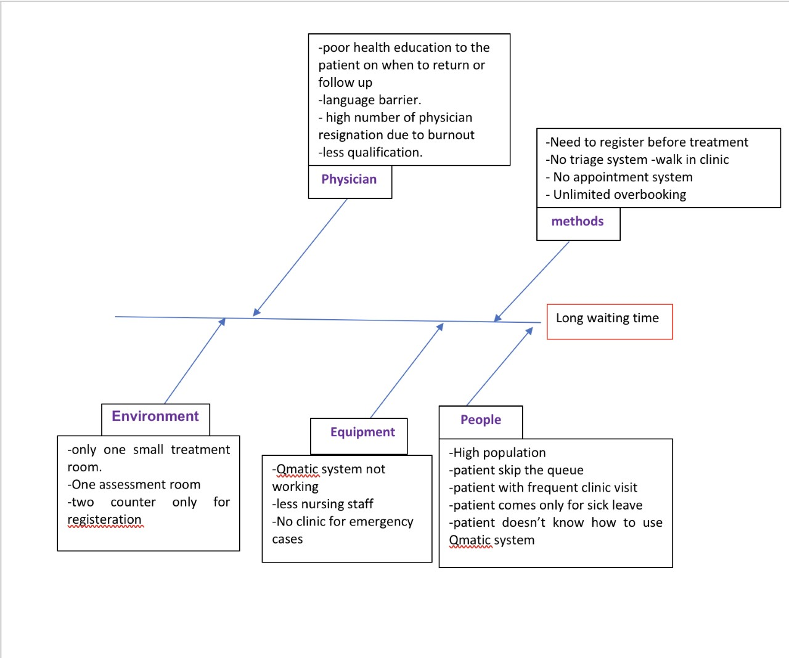

mapping proscess
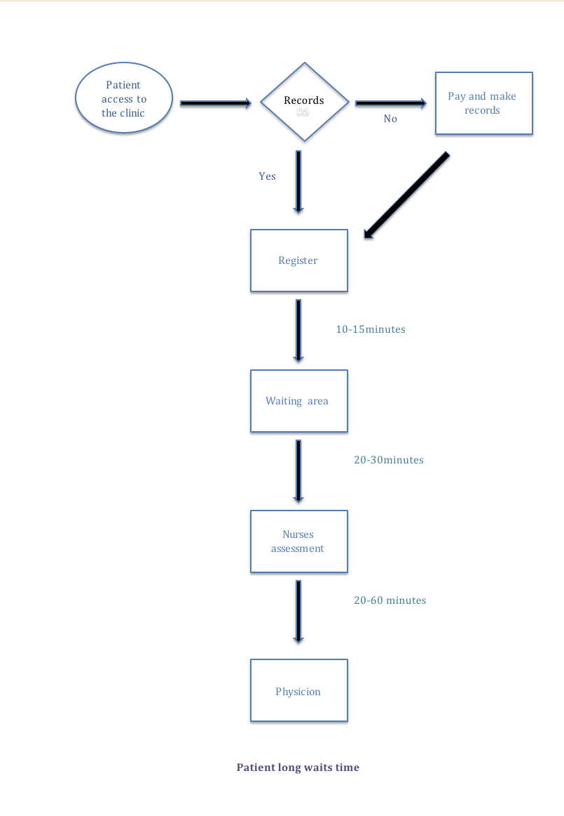

Task | Duration | Progress | Done by
Introduction |  | Not completed | 18161910
Mapping process diagram | 1 day | Completed | 18161910
Context | 7 days | 80% completed | 18161910
Fish bone diagram | 1 day | Completed | 18161910
Fish bone | 2 days | Completed | 18161910
Five whys | 1 day | Completed | 18161910
Discussion | 7 days | Under process | 18199381
Conclusion | 1 days | Completed | 18199381
Gantt chart

References
Bullivant (2000). Managing projects to a successful conclusion
Dowding, D., Randell, R., Gardner, P., Fitzpatrick, G., Dykes, P., Favela, J., ... & Currie, L. (2015). Dashboards for improving patient care: review of the literature. International journal of medical informatics, 84(2)
Grol, R., Wensing, M., Eccles, M., & Davis, D. (Eds.). (2013). improving patient care: the implementation of change in health care. John Wiley & Sons.
Kaplan, B., & Harris-Salamone, K. D. (2009). Health IT success and failure: recommendations from literature and an AMIA workshop. Journal of the American Medical Informatics Association, 16(3), 291-299.
Larson, E. W., & Gray, C. F. (2015). A Guide to the Project Management Body of Knowledge: PMBOK (®) Guide. Project Management Institute.
Medeiros, D. J., Swenson, E., & DeFlitch, C. (2008, December). Improving patient flow in a hospital emergency department. In Proceedings of the 40th conference on winter simulation (pp. 1526-1531). Winter Simulation Conference.
Nowak, M., Pfaff, H., & Karbach, U. (2017). Does Value Stream Mapping affect the structure, process, and outcome quality in care facilities? A systematic review. Systematic reviews, 6(1), 170.
Operations management and Quality 6 essential actions to improve unscheduled care
Pandit, J. J., Pandit, M., & Reynard, J. M. (2010). Understanding waiting lists as the matching of surgical capacity to demand: are we wasting enough surgical time?. Anaesthesia, 65(6), 625-640.
Patient flow- huddles guidance document- NHS Scotland
Pickerden, A. (2015). Planning and Managing your Work Based Project: A Guide For Students.
Scoville, R., & Little, K. (2014). Comparing lean and quality improvement. IHI White Paper.
Rutman, L., Stone, K., Reid, J., Woodward, G. A. T., & Migita, R. (2015). Improving patient flow using lean methodology: an emergency medicine experience. Current Treatment Options in Pediatrics, 1(4), 359-371.
Tiamaz (2017). Extended classification of waste in hospitals system
Womack, J. P., Byrne, A. P., Fiume, O. J., Kaplan, G. S., & Toussaint, J. (2005). Going lean in health care. Cambridge, MA: Institute for Healthcare Improvement.
Di Somma, S., Paladino, L., Vaughan, L., Lalle, I., Magrini, L., & Magnanti, M. (2015). Overcrowding in emergency department: an international issue. Internal and emergency medicine, 10(2), 171-175.
Cordeiro, E., Dixon, M., Coburn, N., & Holloway, C. M. (2015). A patient-centered approach to wait times in the surgical management of breast cancer in the Province of Ontario. Annals of surgical oncology, 22(8), 2509-2516.
Hoot, N. R., & Aronsky, D. (2008). Systematic review of emergency department crowding: causes, effects, and solutions. Annals of emergency medicine, 52(2), 126-136.
Chen, Z., King, W., Pearcey, R., Kerba, M., & Mackillop, W. J. (2008). The relationship between waiting time for radiotherapy and clinical outcomes: a systematic review of the literature. Radiotherapy and Oncology, 87(1), 3-16.
Trebble, T. M., Hansi, N., Hydes, T., Smith, M. A., & Baker, M. (2010). Process mapping the patient journey through health care: an introduction. Bmj, 341(7769), 394-397.

